**AR101 – COMPUTER ORGANIZATION AND ARCHITECTURE**

**ASSIGNMENT NO 1 – Final Term** (Week 11)



**NAME:** **Gregorio, Joey B.**

**STUDENT NO: 20-2261**

**YEAR/SECTION: SBIT-3L**

**DATE: November 14, 2022**



SOLVE SOME EXAMPLES BASED ON THE SLIDE

DAS INSTRACTIONS

MOV AL, 34H

MOV BL, 19H

SUB AL, BL

DAS

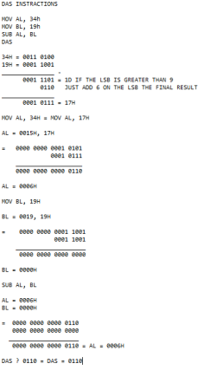

MOV AL, 39H

MOV BL, 34H

SUB AL, BL

AAS

